Greetings fellow Sons and Legion Family members,
In alignment with the American Legion Family’s continuing BE THE ONE theme, my theme this year is You’re the One to Be the One. Each of us can BE THE ONE to make a difference to our communities, state, and nation through our programs that focus on veterans, the military and their families, and by promoting Americanism, supporting Children and Youth initiatives, engaging in The American Legion’s legislative advocacy work, and participating in community service and civil preparedness. No one can do it all, but everyone can do something, and that one thing may be the action that makes a difference. Together we as an organization can BE THE ONE through our collective mission-driven activities.
American Legion Family members are also specifically charged this year with educating ourselves to be able to identify the warning signs exhibited by those who may be contemplating self-harm, and to be aware of resources that are available for immediate intervention. There are approximately 17 veterans who take their own lives every day. Our task is not to become mental health professionals, but rather to know who to contact for immediate crisis intervention when necessary.
My personal project this year is to raise funds and support Veterans and Athletes United, an all-volunteer 501c3 non-profit organization run by veterans, whose mission is “To empower wounded, injured and ill veterans to fully live their lives and honor our fallen military heroes”. This organization provides adaptive sports/recreation activities, accessible retreats, and networking opportunities through its VetNet program. Additionally, it exhibits the travelling Global War on Terror Memorial Flag at special events in the eastern portion of the U.S., and another was recently completed to travel west of the Mississippi. The purpose of these travelling GWOT Memorial Flags constructed of dog tags of the fallen is to raise awareness of the sacrifice paid by America’s heroes to protect our freedom. For more information about the great work done by Veterans and Athletes United, go to https://www.vetsau.com/
Throughout this 2023-2024 administrative year, I challenge you to join me to BE THE ONE to make a difference, to retain a member, to recruit a member, to be mission-driven, to support our programs and to support Veterans and Athletes United.
For God and Country,

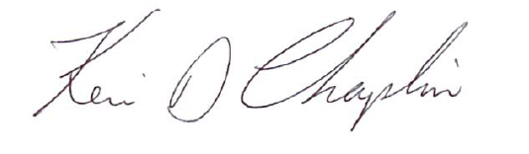

Kevin Chaplin
Commander, Detachment of Virginia, 2023-2024

